MarineSDMs
Marine Species Distribution Models
Benjamin D. Best
2024-03-15
Table of contents

1. Introduction

1.1 Background
The best available global distributions are presently AquaMaps (Kaschner et al. 2006; Ready et al. 2010) with supplementation by IUCN RedList range maps. These have been used to calculate the biodiversity within national waters (Halpern et al. 2012) as well as beyond in the high seas (Visalli et al. 2020).

1.2 Goals
This book aims to capture the overview and details of modeling species distributions in the marine environment for the purposes of advancing the status quo of global and U.S. national species distributions along the following dimensions:
- Space
The current AquaMaps distributions are $1/2$º (~55 km at equator), whereas the best available global bathymetry is $1/240$º (< 0.5 km).
- Time
The current AquaMaps distributions are based on static climatic averages over all seasons, which does not capture temporal dynamics: seasonally within a year, nor long-term climate change trends. This will necessitate sampling the environment contemporaneously with species observations before fitting the model and predicting to different environmental snapshots.
- Environment
Other environmental variables besides the initial physiographic (depth) and oceanographic (temperature, chlorophyll, primary productivity and ice) may elicit an improved statistical fit, related to species’ environmental niche. Some candidates include: temperature fronts, eddy kinetic energy, distance from shore, distance from shelf.
- Biology
Where sufficient observations exist, additional models should be developed highlighting differences between:
  - Life stage, e.g. larval vs adult.
  - Gender where varies, such as male sperm whales being more cosmopolitan.
  - Subpopulations for understanding metapopulation dynamics
  - Behavior, such as migrating, feeding or breeding.
By definition MBONMarine Biodiversity Observation Network; see MarineBON.org is a network, so this is inclusive of and meant for all participants.

1.3 Motivations
- AquaMaps.org
AquaMaps (Kaschner et al. 2006; Ready et al. 2010) represents a massive amount of work to gather parameters for >33.5K marine species, including areas to mask out.
- OBIS.org
The Ocean Biogeographic Information System (Klein et al. 2019; Grassle 2000) is the central portal for continuously added observations with extra flags for quality control, all of which makes marine SDMs possible.
- Modeling methods have dramatically improved over time and are ripe for fresh application. The R package dismo originally came came out with an SDM vignette as a practical supplement to their excellent review of SDMs (Elith and Leathwick 2009) and using the Maxent algorithm (Elith et al. 2011). The raster package furthered that (raster sdm) and now there’s terra sdm. Alongside these developments has been a boon of cloud-computing, particularly Google Earth Engine (Gorelick et al. 2017; Campos et al. 2023), allowing for dense global raster processing.
- The world is quickly moving towards a future trying to conserve 30% of the oceans by 2030, so called “30 by 30”. In the U.S., this is America the Beautiful initiative (Carroll, Noss, and Stein 2022) for which MBONMarine Biodiversity Observation Network; see MarineBON.org is well poised to inform (Fautin et al. 2010; Muller-Karger et al. 2018). We need biodiversity indicators to track progress. This push for conservation is driven by increasing impacts of climate change, as evidenced by marine heatwaves and shifts in population distributions.

1.4 Process
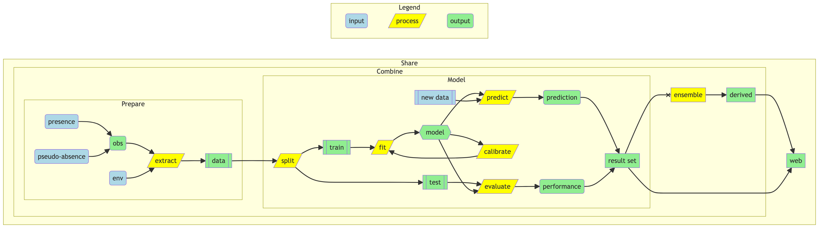
Figure 1.1: Diagram of SDM data preparation and model fitting.

1.5 Contribute
We very much welcome your feedback, contributions and collaboration. As soon as you contribute, we will add you to to the authors list. Here are a few ways to contribute from least to most involved:
- Email Ben (ben@ecoquants.com) with any suggestions, including suggested revisions of this online book.
-  Note
- Note that you can download this entire book as:
  - Adobe Acrobat pdf to add annotations; or
  - Microsoft Word docx to edit with Track Changes on.
- These are available in the upper left navigation menu by clicking the download icon .
- Submit a New Issue on Github.
- Click on “ Edit this Page” in the upper right. If you have a Github account, then you can fork this repository from owner “marinebon” to your username, edit the page(s) and submit a pull request. See Hello World - GitHub Docs.
- If you are a regular contributor, you can be added to the collaborators of this repository to push changes directly (without needing a pull request).

1.6 Features
This Quarto book has a few cool features:
- Multiple formats
From the singe set of source Quarto documents (*.qmd), several output formats are rendered: html, pdf, docx. This is particularly helpful when suggesting changes. It also lends itself well to being carved into manuscripts.
- Self-rendering
Github hosts the web pages (*.html), which get rendered from the source code (*.qmd) using a Github Action. So edits can be made simply through the web interface and all outputs get updated (html, pdf, docx). It also ensures the reproducibility of the document with a common setup environment.
- Mermaid diagrams
e.g., Figure 1.1, Figure 3.1, Figure 7.1
- Quarto document listings
- References
- Glossary
- Search

2. Prepare
Prepare observations and environmental data for modeling

3. Prepare
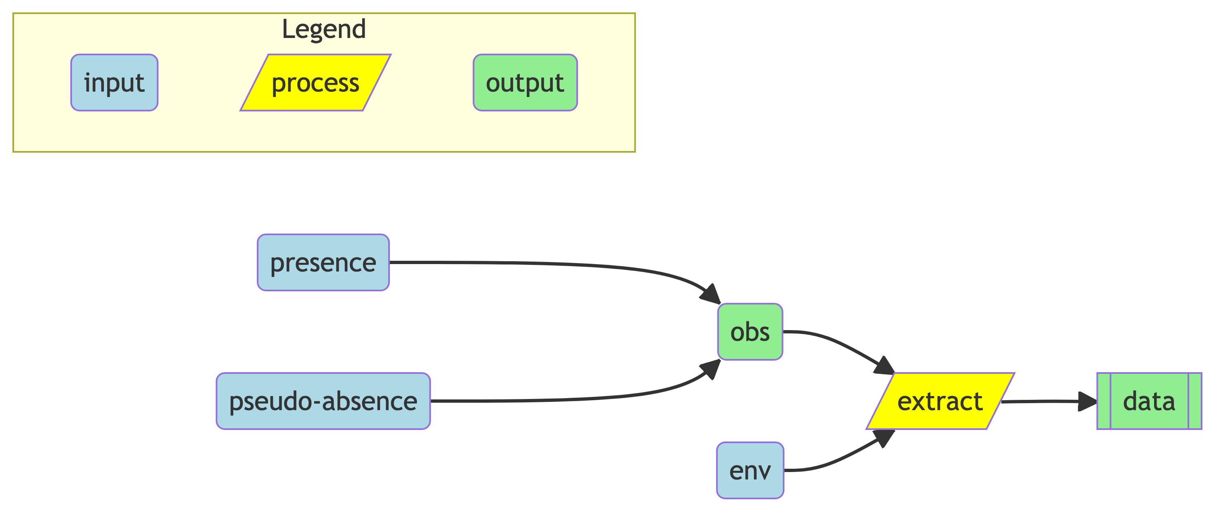
Figure 3.1: Diagram of SDM data preparation for model fitting.
- obs
observations: occurrences from OBIS; masked by FAO regions defined by AquaMaps (Skyttner 2020)
  - presence
OBIS: species occurrence
  - absence
OBIS not-species, but same family
- env
environment
- tbl
table of observations (presence and absence) with environmental values

3.1 Environmental Predictors

3.1.1 Physiographic
- depth
Bathymetric Depth
- d2coast
Distance to Coast
- d2shelf
Distance to Shelf

3.1.2 Time Varying
- vgpm
Vertically integrated primary Productivity model

3.1.3 Depth & Time Varying
- temp
Temperature, either sea-surface temperature (SST) or some modeled product from HyCOM, ROMS or Copernicus
- salin
Salinity

4. Occurrences
Fetch presence observations and filter for quality control

To describe:
- robis
- Filter based on quality flags
- Remove outliers
  - eks
Tidy and Geospatial Kernel Smoothing for spatially filtering outlier observations
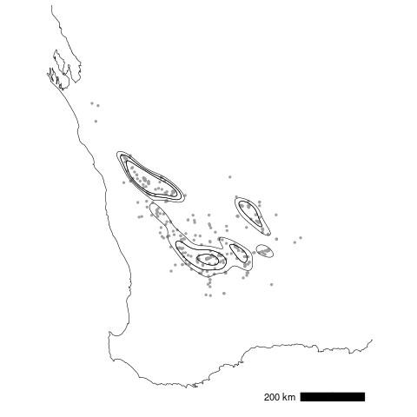
Figure 4.1: Source: Kernel density estimates for tidy and geospatial data in the eks package

4.1 Fetch OBIS

4.2 Filter occurrences

5. Pseudo-absences
Generate pseudo-absence or background environmental values to compare with occurrence environment

Describe various strategies for generating pseudo-absences.
- Pseudo-absences • biomod2
  - (Barbet-Massin et al. 2012)

5.1 All background
A common Maxent strategy is to feed all background points into Maxent, and then to use the resulting distribution as a null model. This is the default strategy in Maxent (Phillips et al. 2017; Phillips, Anderson, and Schapire 2006; Phillips and Dudík 2008).

5.2 Mask by FAO areas
The FAO areas applicable to species are included in the aquamapsdata, presumably from evaluating OBIS observations and the literature.

5.3 Use occurrences from same Family, different species
By using the same family, we can be sure that the pseudo-absences are ecologically similar to the species of interest.

6. Environment
Extract environmental predictors (static and/or dynamic) from various sources for observations (presence and pseudo-absence)

Environmental data are used to fit the model and predict distribution onto the seascape, e.g. Table 6.1.
Table 6.1: Example of environmental predictors from Roberts et al. (2016).
librarian::shelf(
here, knitr, readr)
library(here)
library(knitr)
library(readr)
d <- read_csv(
here("data/Roberts-2016_env-predictors.csv"),
show_col_types = F)
options(knitr.kable.NA = '')
kable(d, format="pipe")
Type /Covariates | Resolution | Time range | Description
Physiographic
Depth, Slope | 30 arc sec |  | Seafloor depth and slope, derived from SRTM30-PLUS global bathymetry20
DistToShore, DistTo125m, DistTo300m, DistTo1500m | 30 arc sec |  | Distance to the closest shoreline, excluding Bermuda and Sable Island, and various ecologically-relevant isobaths20
DistToCanyon, DistToCanyon OrSeamount | 30 arc sec |  | Distance to the closest submarine canyon, and to the closest canyon or seamount21
SST & Winds
SST, DistToFront | 0.2°, daily | 1991-2014 | Foundation sea surface temperature (SST), from GHRSST Level 4 CMC SST22, and distance to the closest SST front identified with the Canny edge detection algorithm23
WindSpeed | 0.25°, daily | 1991-2014 | 30-day running mean of NOAA NCDC 1/4° Blended Sea Winds24
Currents
TKE, EKE | 0.25°, daily | 1993-2013 | Total kinetic energy (TKE) and eddy kinetic energy (EKE), from Aviso 1/4° DT-MADT geostrophic currents
DistToEddy, DistToAEddy, DistToCEddy | 0.25°, weekly | 1993-2013 | Distance to the ring of the closest geostrophic eddy having any (DistToEddy), anticyclonic (DistToAEddy), or cyclonic (DistToCEddy) polarity, from Aviso 1/4° DT-MADT using a revision of the Chelton et al. algorithm25; we tested eddies at least 9, 4, and 0 weeks old
Biological
Chl | 9 km, daily | 1997-2014 | GSM merged SeaWiFS/Aqua/MERIS/VIIRS chlorophyll (Chl) a concentration26, smoothed with a 3D Gaussian smoother to reduce data loss to < 10%
VGPM, CumVGPM45, CumVGPM90 | 9 km, 8 days | 1997-2014 | Net primary production (mg C m-2 day-1) derived from SeaWiFS and Aqua using the Vertically Generalized Production Model (VPGM)27; we tested the original 8 day estimates as well as 45 and 90 day running accumulations
PkPP, PkPB | 0.25°, weekly | 1997-2013 | Zooplankton production (PkPP; g m-2 day-1) and biomass (PkPB; g m-2) from the SEAPODYM ocean model28
EpiMnkPP, EpiMnkPB | 0.25°, weekly | 1997-2013 | Epipelagic micronekton production (EpiMnkPP; g m-2 day-1) and biomass (EpiMnkPB; g m-2) from the SEAPODYM model(28)

6.0.1 Physiographic
- depth
Bathymetric Depth
- d2coast
Distance to Coast
- d2shelf
Distance to Shelf

6.0.2 Time Varying
- vgpm
Vertically integrated primary Productivity model

6.0.3 Depth & Time Varying
- temp
Temperature, either sea-surface temperature (SST) or some modeled product from HyCOM, ROMS or Copernicus
- salin
Salinity

7. Model
Model the distribution of a species

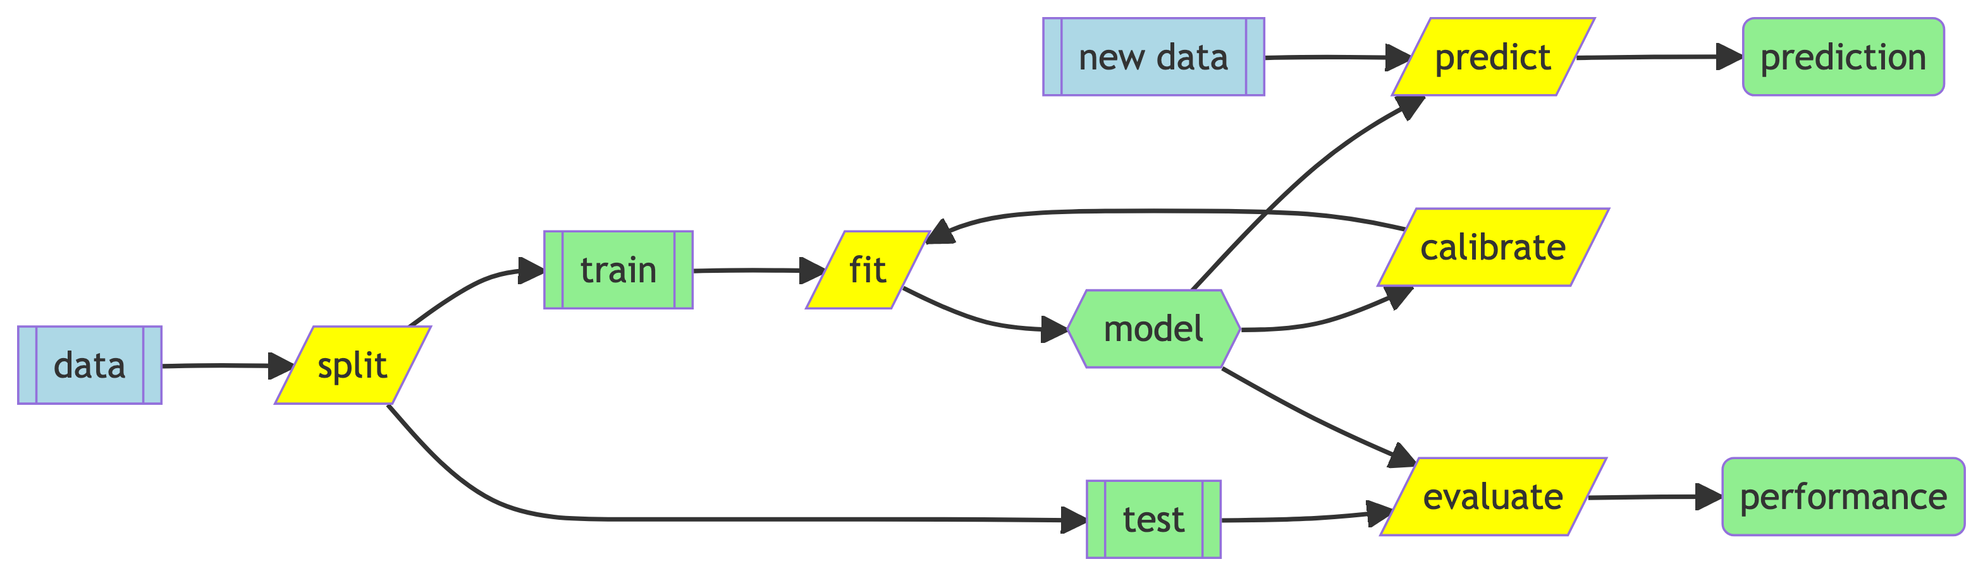
Figure 7.1: Diagram of SDM Modeling processes.

8. Split
Split data into training (to fit) and test (to evaluate prediction)

Data is often split so that ~20% of the observations (presence and absence) are set aside from the model fitting to be used for model evaluation.
The k-fold function is often used to split the data into k groups, and then the model is fit k times, each time using a different group as the test data and the remaining groups as the training data.

9. Fit
Fit environmental relationship distinguishing presence from absence of species

Model fitting in theory is quite complex, but quite simple in practice, with feeding the prepared data into the modeling function.
However there are MANY modeling techniques from which to choose. For instance check out 238 entries in 6 Available Models | The caret Package.

10. Calibrate
Calibrate model fit, i.e., model selection

The process of refining the model to only the most relevant environmental predictor terms is commonly called “Model Selection.” One of the most cited scientific paper of all time (Akaike 1974) is based on taking a most parsimonious approach to this process – the so called Akaike Information Criteria (AIC).
It is important to avoid using environmental predictors that are correlated with each other, since the effect of a predictor on the response could be the ecologically inverse, the result of explaining variance on the residuals of the other correlated predictor.

11. Predict
Predict distribution of the species with environmental relationship from fitted model

The prediction step applies the environmental relationships from the fitted model to a new set of data, typically the seascape of interest, and perhaps with some sort of temporal snapshot (e.g., climatic annual or monthly average).

12. Evaluate
Evaluate performance of the predicted model with the test data

Model evaluation uses the set aside test data from the earlier splitting to evaluate how well the model predicts the response of presence or absence. Since the test response data is binary [0,1] and the prediction from the model is continuous [0-1], a threshold needs to be applied to assign to convert the continuous response to binary. This is often performed through a Receiver Operator Characteristic (ROC) curve (Figure 12.1), which evaluates at each threshold the confusion matrix (Table 12.1).
Table 12.1: Confusion matrix to understand predicted versus observed.
 |  | Predicted
 |  | 0 (absence) | 1 (presence)
Observed | 0 (absence) | True absence | False presence
 | 1 (presence) | False absence | True presence

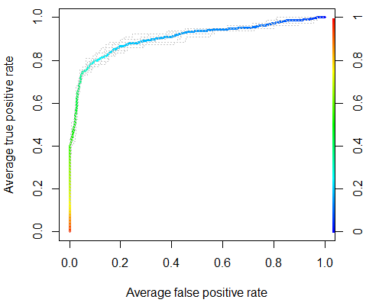
Figure 12.1: ROC curve generated by showing rates of false positive vs false negative as function of changing the threshold value (rainbow colors). Source: ROCR: visualizing classifier performance in R
From the ROC curve, the area under the curve (AUC) is calculated, which is a measure of the model’s ability to distinguish between presence and absence. AUC values range from 0 to 1, with 0.5 being no better than random, and 1 being perfect.

12.1 More Resources
- Classification: ROC Curve and AUC | Machine Learning | Google for Developers

13. Combine
Combine SDMs from the same or multiple species

We look at combining SDMs to calculate biodiversity based on addressing questions of interest and relevance.
- See joint species distribution models (jSDMs) per Hartig et al (2023, Box 2) that includes species co-occurrence.

14. Ensemble
- biomod2
Species distribution modeling, calibration and evaluation, ensemble modeling
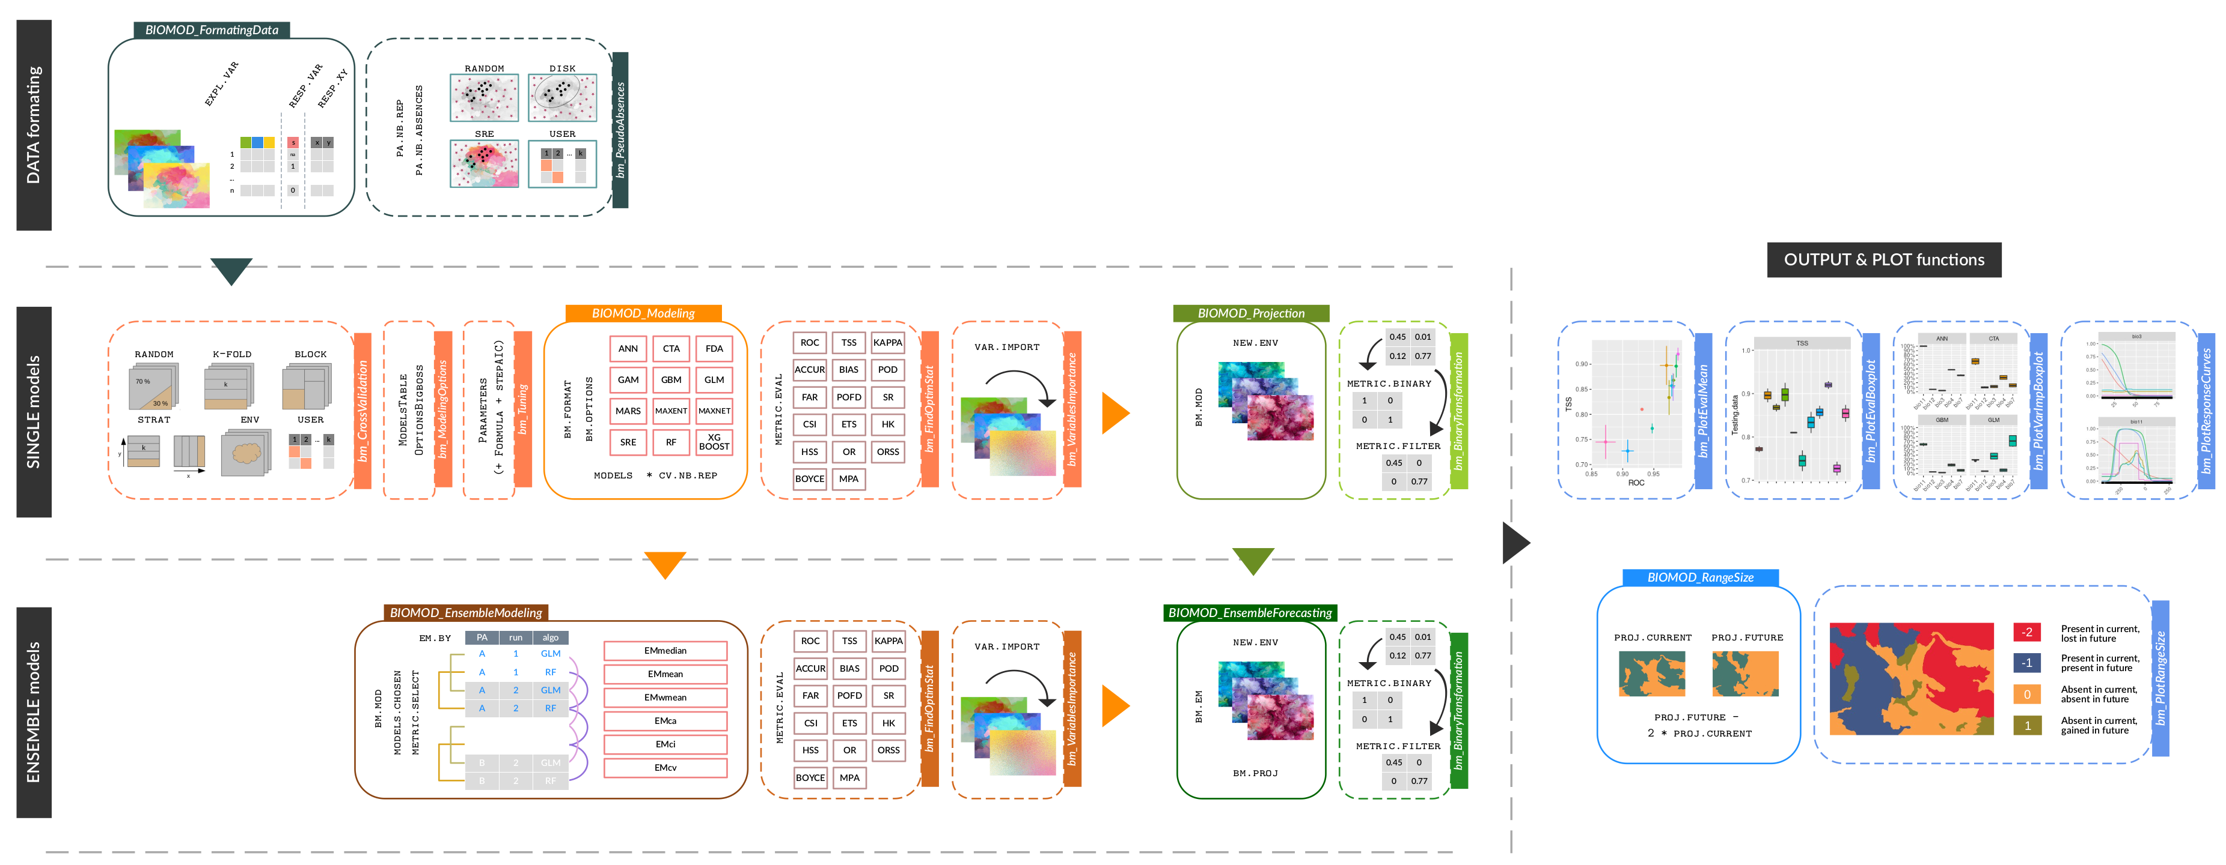

15. Mosaic
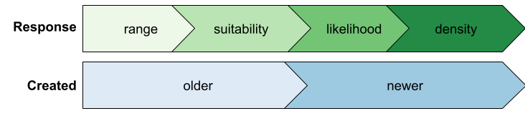
Figure 15.1: Hierarchy of preferred model outputs based on response type and age.
This is illustrated well by Figure 15.1.

16. Taxa
Group SDMs by taxanomy

Taxonomic groups (Tittensor et al. 2010) in the high seas (Visalli et al. 2020) were packaged with simple query statements in the draft R package gmbi (global marine biodiversity indicators).

17. Indicators
Calculate indicators of ecological or management interest beyond taxonomic groupings

17.1 Diversity
Here are the classic diversity indices from the R package vegan:
$$\begin{matrix}H & =−\sum_{i=1}^{S}{p_{i}}\log_{b}p_{i} & \text{Shannon-Weaver} \\ D_{1} & =1−\sum_{i=1}^{S}{p_{i}^{2}} & \text{Simpson} \\ D_{2} & =\frac{1}{\sum_{i=1}^{S}{p_{i}^{2}}} & \text{inverse Simpson}\end{matrix}$$
where $p_{i}$ is the proportion of species $i$, and $S$ is the number of species so that $\sum_{i=1}^{S}{p_{i}}=1$, and $b$ is the base of the logarithm.

17.2 Endemism
Endemism could be measured as a function of the presence or average of the species range, given by either a global SDM converted to a binary range or using the existing IUCN range maps.

17.3 Extinction Risk
This is provided by IUCN RedList, as well as sometimes at a national level, such as NatureServe’s Conservation Status Ranks for the U.S.

17.4 Functional Importance

17.5 Habitat Forming
Habitat forming species, such as coral, mangrove, seagrasses and kelp are especially important for biodiversity and ecosystem services.

17.6 Phylogenetic Uniqueness

17.7 Richness

17.8 Sensitivity
Sensitivity to specific human activities, such as shipping or fishing. Some activities may have different stages of development, such as construction versus operation of offshore wind energy.

17.9 Trophic Index

18. Share
Metadata standards and portals to share SDMs

19. Metadata
Metadata standards for reproducible and stackable SDMs

What standards (Araújo et al. 2019; Kass et al. 2023; Zurell et al. 2020) are required for models to be hosted?
- input
  - input observations
  - environmental predictors
and range of values in original observations
  - model type and object
- outputs
  - model object
  - mean prediction
  - measure(s) of uncertainty
standard error, standard deviation (sd), confidence intervals (e.g., 5% and 95%), coefficient of variation (cv)…

20. Portal
Portal to host and combine for user-specific needs

Can we supplement an existing portal or create a new one to host different types of model outputs and combine them?
What are publishing workflows for existing portals?
- Existing portals used to share SDMs
  - AquaMaps Standardized distribution maps for over 33,500 species of fishes, marine mammals and invertebrates
  - DisMAP
Distribution Mapping and Analysis Portal
  - OBIS-SEAMAP Model Repository
World Data Center for Marine Mammal, Seabird, Sea Turtle, Shark & Ray Distributions
  - NCEI
National Centers for Environmental Information (NOAA)
  - DataONE
Data Observation Network for Earth
  - ArcGIS Online
  - Esri’s commercial data sharing platform
- Candidate portal
MarineSpeciesMaps.org
BDB registered the domain. Similar to:
  - MarineRegions.org
spatial authority
  - MarineSpecies.org
taxonomic authority

References
Akaike, H. 1974. “A New Look at the Statistical Model Identification.” IEEE Transactions on Automatic Control 19 (6): 716723.
Araújo, Miguel B., Robert P. Anderson, A. Márcia Barbosa, Colin M. Beale, Carsten F. Dormann, Regan Early, Raquel A. Garcia, et al. 2019. “Standards for Distribution Models in Biodiversity Assessments.” Science Advances 5 (1): eaat4858. https://doi.org/10.1126/sciadv.aat4858.
Barbet-Massin, Morgane, Frédéric Jiguet, Cécile Hélène Albert, and Wilfried Thuiller. 2012. “Selecting Pseudo-Absences for Species Distribution Models: How, Where and How Many?” Methods in Ecology and Evolution 3 (2): 327–38. https://doi.org/10.1111/j.2041-210X.2011.00172.x.
Campos, João C., Nuno Garcia, João Alírio, Salvador Arenas-Castro, Ana C. Teodoro, and Neftalí Sillero. 2023. “Ecological Niche Models Using MaxEnt in Google Earth Engine: Evaluation, Guidelines and Recommendations.” Ecological Informatics 76 (September): 102147. https://doi.org/10.1016/j.ecoinf.2023.102147.
Carroll, C., R. F. Noss, and Bruce A. Stein. 2022. “US Conservation Atlas Needs Biodiversity Data.” Science 376 (6589): 144–45. https://doi.org/10.1126/science.abo0526.
Elith, Jane, and John R. Leathwick. 2009. “Species Distribution Models: Ecological Explanation and Prediction Across Space and Time.” Annual Review of Ecology, Evolution, and Systematics 40 (1): 677–97. https://doi.org/10.1146/annurev.ecolsys.110308.120159.
Elith, Jane, Steven J. Phillips, Trevor Hastie, Miroslav Dudík, Yung En Chee, and Colin J. Yates. 2011. “A Statistical Explanation of MaxEnt for Ecologists.” Diversity and Distributions 17 (1): 43–57. http://dx.doi.org/10.1111/j.1472-4642.2010.00725.x.
Fautin, Daphne, Penelope Dalton, Lewis S. Incze, Jo-Ann C. Leong, Clarence Pautzke, Andrew Rosenberg, Paul Sandifer, et al. 2010. “An Overview of Marine Biodiversity in United States Waters.” PLoS ONE 5 (8): e11914. https://doi.org/10.1371/journal.pone.0011914.
Gorelick, Noel, Matt Hancher, Mike Dixon, Simon Ilyushchenko, David Thau, and Rebecca Moore. 2017. “Google Earth Engine: Planetary-Scale Geospatial Analysis for Everyone.” Remote Sensing of Environment, Big remotely sensed data: Tools, applications and experiences, 202 (December): 18–27. https://doi.org/10.1016/j.rse.2017.06.031.
Grassle, J. Frederick. 2000. “The Ocean Biogeographic Information System (OBIS): An on-Line, Worldwide Atlas for Accessing, Modeling and Mapping Marine Biological Data in a Multidimensional Geographic Context.” Oceanography 13 (3): 5–7. https://www.jstor.org/stable/43924357.
Halpern, Benjamin S., Catherine Longo, Darren Hardy, Karen L. McLeod, Jameal F. Samhouri, Steven K. Katona, Kristin Kleisner, et al. 2012. “An Index to Assess the Health and Benefits of the Global Ocean.” Nature. https://doi.org/10.1038/nature11397.
Hartig, Florian, Nerea Abrego, Alex Bush, Jonathan M. Chase, Gurutzeta Guillera-Arroita, Mathew A. Leibold, Otso Ovaskainen, et al. 2023. “Novel Community Data in Ecology-Properties and Prospects.” Trends in Ecology & Evolution 0 (0). https://doi.org/10.1016/j.tree.2023.09.017.
Kaschner, K., R. Watson, A. W. Trites, and D. Pauly. 2006. “Mapping World-Wide Distributions of Marine Mammal Species Using a Relative Environmental Suitability (RES) Model.” Marine Ecology Progress Series 316 (July): 285–310. https://doi.org/10.3354/meps316285.
Kass, Jamie M., Gonzalo E. Pinilla-Buitrago, Andrea Paz, Bethany A. Johnson, Valentina Grisales-Betancur, Sarah I. Meenan, Dean Attali, et al. 2023. “Wallace 2: A Shiny App for Modeling Species Niches and Distributions Redesigned to Facilitate Expansion via Module Contributions.” Ecography 2023 (3): e06547. https://doi.org/10.1111/ecog.06547.
Klein, Eduardo, Ward Appeltans, Pieter Provoost, Hanieh Saeedi, Abigail Benson, Lenore Bajona, Ana Carolina Peralta, and R. Sky Bristol. 2019. “OBIS Infrastructure, Lessons Learned, and Vision for the Future.” Frontiers in Marine Science 6. https://www.frontiersin.org/articles/10.3389/fmars.2019.00588.
Muller-Karger, Frank E., Patricia Miloslavich, Nicholas J. Bax, Samantha Simmons, Mark J. Costello, Isabel Sousa Pinto, Gabrielle Canonico, et al. 2018. “Advancing Marine Biological Observations and Data Requirements of the Complementary Essential Ocean Variables (EOVs) and Essential Biodiversity Variables (EBVs) Frameworks.” Frontiers in Marine Science 5. https://doi.org/10.3389/fmars.2018.00211.
Phillips, Steven J., Robert P. Anderson, Miroslav Dudík, Robert E. Schapire, and Mary E. Blair. 2017. “Opening the Black Box: An Open-Source Release of Maxent.” Ecography 40 (7): 887–93. https://doi.org/10.1111/ecog.03049.
Phillips, Steven J., Robert P. Anderson, and Robert E. Schapire. 2006. “Maximum Entropy Modeling of Species Geographic Distributions.” Ecological Modelling 190 (3): 231–59. https://doi.org/10.1016/j.ecolmodel.2005.03.026.
Phillips, Steven J., and Miroslav Dudík. 2008. “Modeling of Species Distributions with Maxent: New Extensions and a Comprehensive Evaluation.” Ecography 31 (2): 161–75. https://doi.org/10.1111/j.0906-7590.2008.5203.x.
Ready, Jonathan, Kristin Kaschner, Andy B. South, Paul D. Eastwood, Tony Rees, Josephine Rius, Eli Agbayani, Sven Kullander, and Rainer Froese. 2010. “Predicting the Distributions of Marine Organisms at the Global Scale.” Ecological Modelling 221 (3): 467–78. https://doi.org/10.1016/j.ecolmodel.2009.10.025.
Roberts, Jason J., Benjamin D. Best, Laura Mannocci, Ei Fujioka, Patrick N. Halpin, Debra L. Palka, Lance P. Garrison, et al. 2016. “Habitat-Based Cetacean Density Models for the u.s. Atlantic and Gulf of Mexico.” Scientific Reports 6 (March): 22615. https://doi.org/10.1038/srep22615.
Skyttner, Markus. 2020. “Aquamapsdata: Curated Data from AquaMaps.org.” https://github.com/raquamaps/aquamapsdata.
Tittensor, Derek P., Camilo Mora, Walter Jetz, Heike K. Lotze, Daniel Ricard, Edward Vanden Berghe, and Boris Worm. 2010. “Global Patterns and Predictors of Marine Biodiversity Across Taxa.” Nature 466 (7310): 1098–1101. https://doi.org/10.1038/nature09329.
Visalli, Morgan E., Benjamin D. Best, Reniel B. Cabral, William W. L. Cheung, Nichola A. Clark, Cristina Garilao, Kristin Kaschner, et al. 2020. “Data-Driven Approach for Highlighting Priority Areas for Protection in Marine Areas Beyond National Jurisdiction.” Marine Policy, March, 103927. https://doi.org/10.1016/j.marpol.2020.103927.
Zurell, Damaris, Janet Franklin, Christian König, Phil J. Bouchet, Carsten F. Dormann, Jane Elith, Guillermo Fandos, et al. 2020. “A Standard Protocol for Reporting Species Distribution Models.” Ecography 43 (9): 1261–77. https://doi.org/10.1111/ecog.04960.

Glossary
glossary::glossary_table(as_kable=F) |>
knitr::kable("pipe", escape = F, row.names = F)
term | definition
MBON | Marine Biodiversity Observation Network; see MarineBON.org

AquaMaps Downscaled
Downscale AquaMaps from 1/2º to GEBCO 1/240º using Google Earth Engine and Shiny.
- website
- code
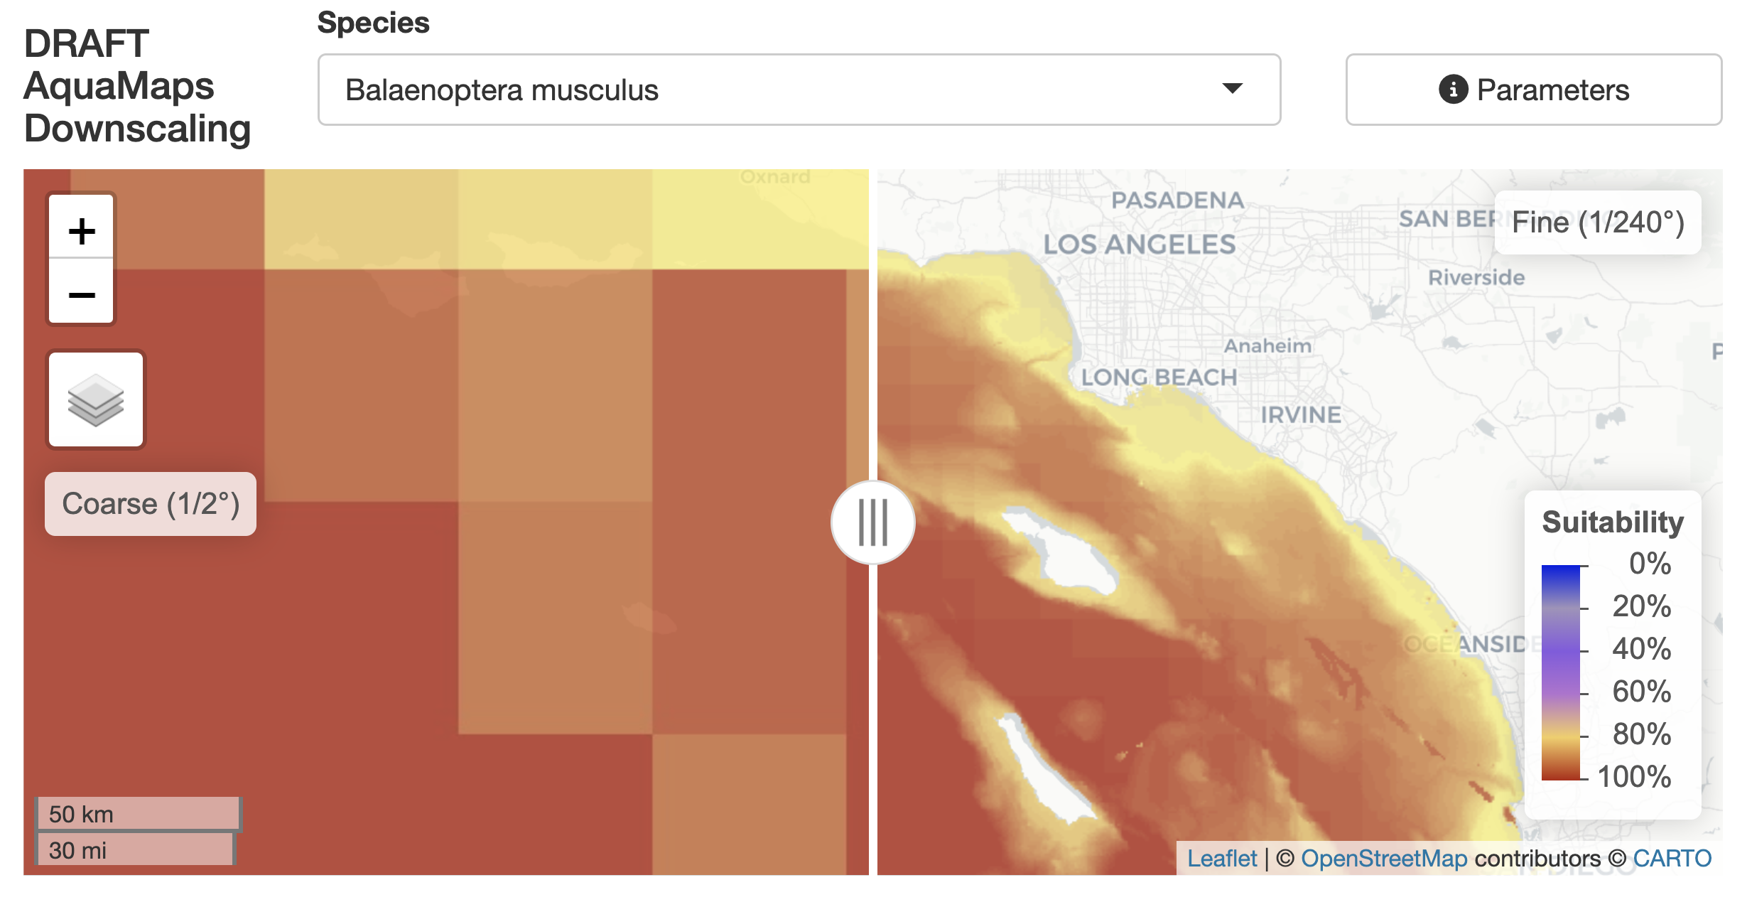

AquaMaps Envelope
Extract and plot AquaMaps environmental envelope, ramp rasters, using R.
- website
- code
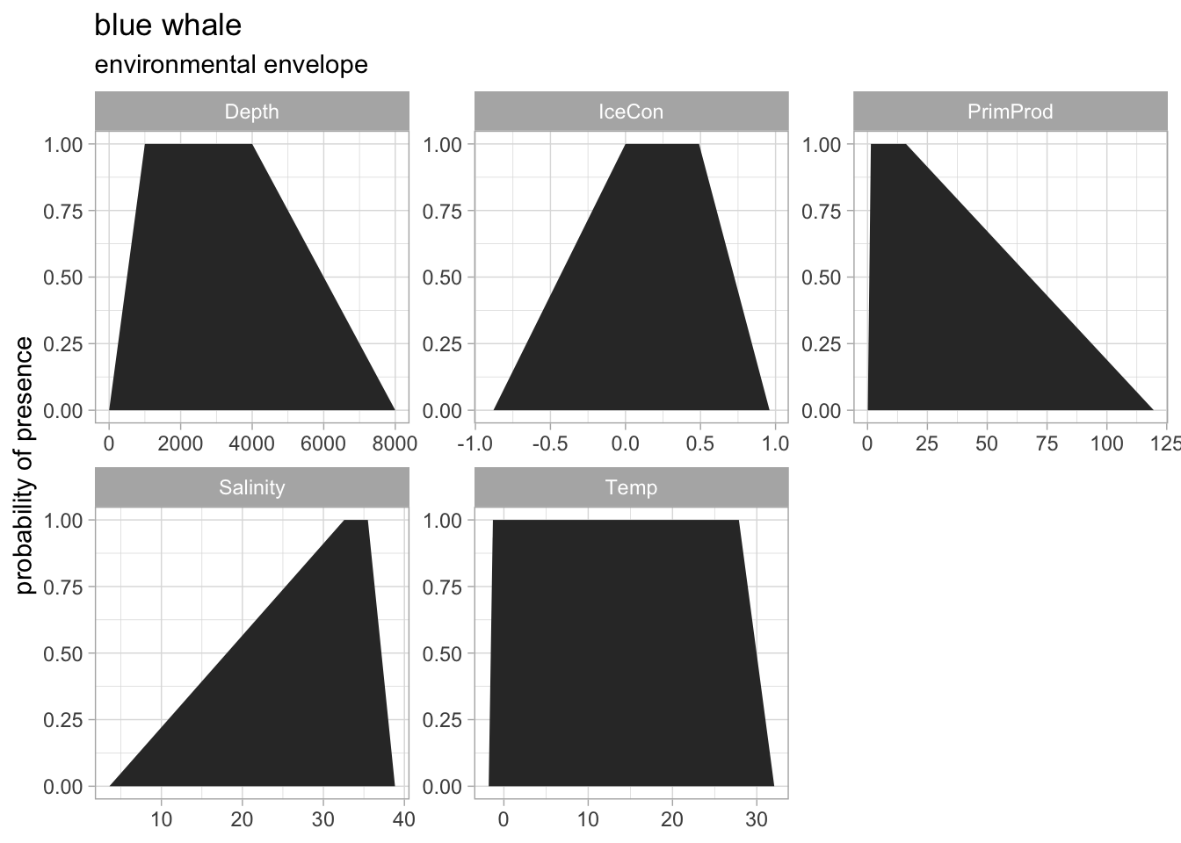

AquaMaps Treemap
Select a Sanctuary or Draw a polygon to filter to 1/2º AquaMaps species and view as Table or treemap Plot for interactive taxonomic composition.
- website
- code
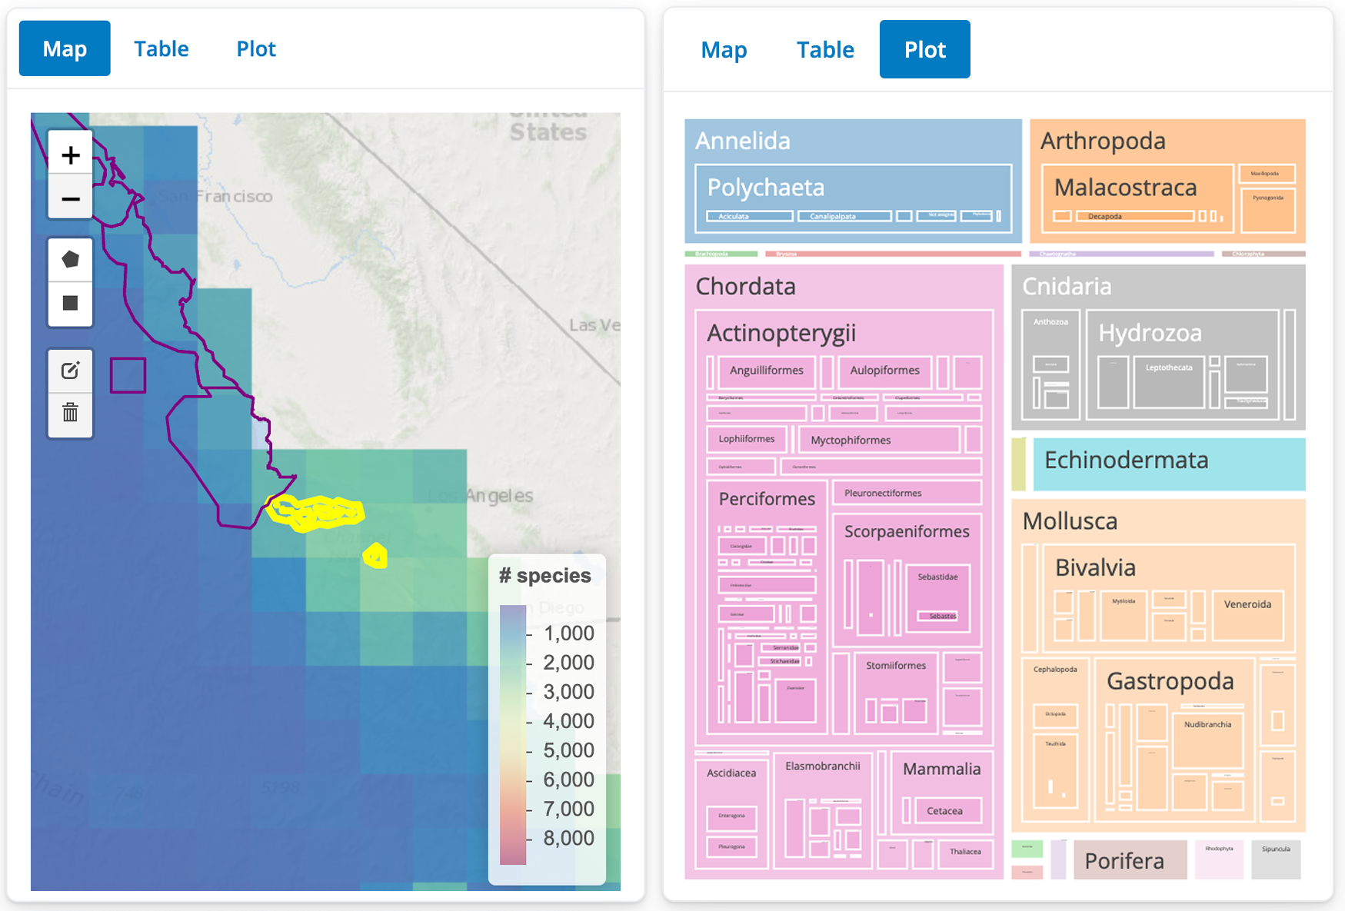
This app uses aquamapsdata after translating from sqlite (slow) and raster (deprecated) R functions to duckdb (fast) and terra (superceding) R functions. We can use these distributional data to calculate place-based indicators with anticipation of the distributional data getting improved upon in 2024 by AquaX and others.

SDM predicts
Predict species distribution of N Atlantic right whale using OBIS occcurrences and predicts package in R.
- website
- code
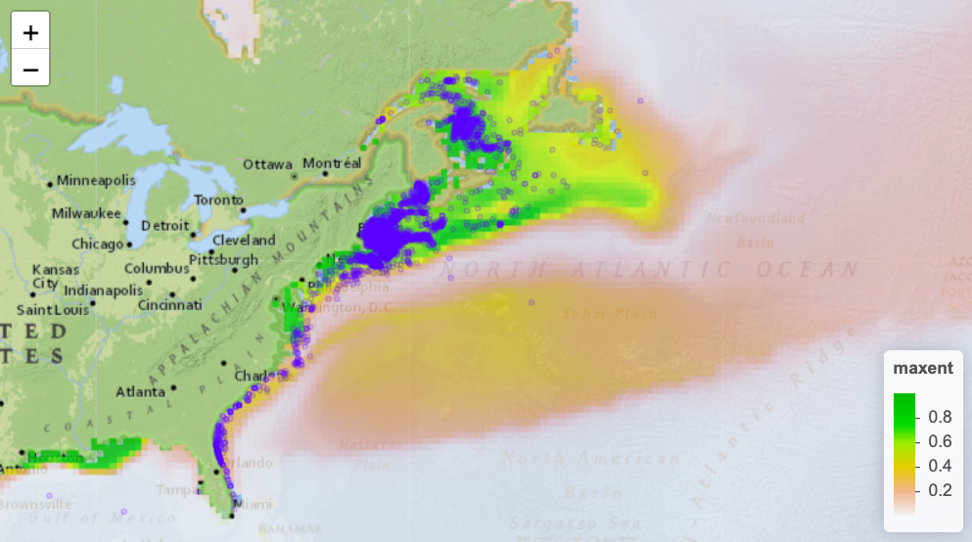

OBIS Top Classes
Extract the species with the most numerous observations by unique Class from the OBIS parquet archive in R.
- website
- code
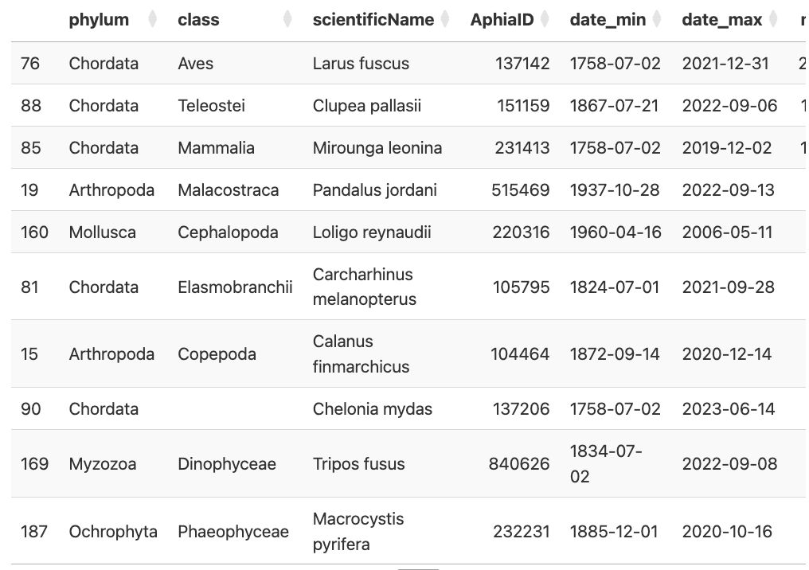

Software

R
Most packages have not yet migrated from using the deprecated raster R package to the new terra package, except for biomod2 (ref?).
- biomod2
Species distribution modeling, calibration and evaluation, ensemble modeling
- eks
Tidy and Geospatial Kernel Smoothing for spatially filtering outlier observations
Figure 20.1: Source: Kernel density estimates for tidy and geospatial data in the eks package
- predicts
New R library using terra for predicting from fitted model

Python
- Xarray
Xarray makes working with labelled multi-dimensional arrays in Python simple, efficient, and fun!

Google Earth Engine
- XEE
XEE is a new Python package for Earth Engine that provides a set of functions to facilitate the use of Earth Engine API. It is designed to be used in Jupyter notebooks and Google Colab. Documentation

IUCN RedList range maps: https://www.iucnredlist.org/resources/spatial-data-download

